Batch: **D2** Roll No.: **16010221038**

Experiment / assignment / tutorial No. **7** Grade: AA / AB / BB / BC / CC / CD /DD

Signature of the Staff In-charge with date

**Title:** Compound pendulum

CO6: Analyze the dynamic system using D’Alembert, work energy and impulse momentum principle.

# Objective

To determine the center of gravity as well as the radius of gyration about the center of gravity by using compound pendulum.

# Theory

Consider an extended body of mass with a hole drilled though it. Suppose that the body is suspended from a fixed peg, which passes through the hole, such that it is free to swing from side to side. This setup is known as a compound pendulum.

Any object mounted on a horizontal axis so as to oscillate under the force of gravity is a compound pendulum. The one used in this experiment is a uniform rod suspended at different locations along its length.

**AIM :**

To find the radius of gyration of a compound pendulum and determine acceleration due to gravity.

**APPARATUS**

Compound pendulum, knife edge, meter scale and stop watch.

**Setup Diagram:**

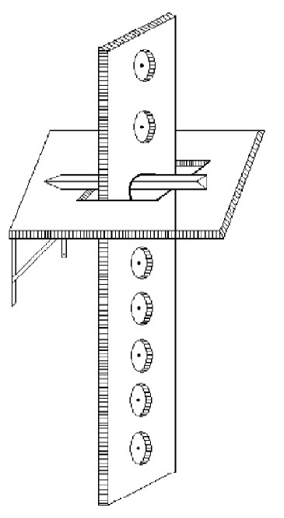

**PROCEDURE :**

1. Find the centroid of the compound pendulum by balancing it on a knife edge
2. Keep the knife edge screw in the 1st hole of the compound pendulum and tighten the screw so that the sharp edge of the knife edge is exactly downwards. Let us call this side as side A.
3. Measure the length ‘h’ between the point of the suspension and the centre of gravity
4. Suspend the pendulum from the knife edge and ensure that the knife edge rests on the rigid horizontal surface (so that the pendulum oscillates in a vertical plane) 5) Set the pendulum to oscillate with a small amplitude(less than 10 degree)
5. Note the time required for 20 oscillations (t), using a stop watch. Repeat this once more and find the average time required for 20 oscillations. from this average time, calculate the time required for one oscillation(i.e., the time period for the pendulum T)

T = t/20

1. Repeat the step no 6 four more times, keeping the knife edge on the 3rd, 5th, 7th, 9th holes.
2. Calculate h2 and hT 2 in each case
3. Plot the graph of hT 2vs h2, which will be straight line. Find the slope and the intercept of the line on the hT2 axis (For plotting this line, use the line of the best fit explained later). From the slope of the line find the value of ‘g’ and from the intercept, find the value of ‘k’

Repeat the procedure for side b of the pendulum

From the relation T = 2(*h*2 +*k* 2 )1/2

 *gh* 

T2.h = 4*g*2 *h*2 42 *k*2

+ *g* 

Thus the plot of hT2 vs h2 will be a straight line, as the above equation of the form y= mx +c where m is the slope and c is the intercept on the y axis.

From the slope of the line m = 4*g*2  4.II2/g, we can calculate the value of ‘g’ 

From the intercept c =4*g*2 *k*2, we can calculate the value of ‘k’

**OBSERVATION TABLE**

|  |  |  |  |  |  |  |  |  |
| --- | --- | --- | --- | --- | --- | --- | --- | --- |
| Hole No. | h  (cm) | Time for 20 oscillations (t)(sec) | | | T= t/20  (sec) | T² (sec²) | h²  (cm²) | hT² |
| 1 | 2 | mean |
| 1 | 44 | 32 | 32 | 32 | 1.6 | 2.56 | 1936 | 112.64 |
| 3 | 34.5 | 30 | 30 | 30 | 1.5 | 2.25 | 1190.25 | 77.625 |
| 5 | 24 | 30 | 30 | 30 | 1.5 | 2.25 | 576 | 54 |
| 7 | 14 | 34 | 34 | 34 | 1.7 | 2.89 | 196 | 40.46 |
| 9 | 5 | 53 | 53 | 53 | 2.65 | 7.02 | 25 | 35.1 |

**CALCULATION:**

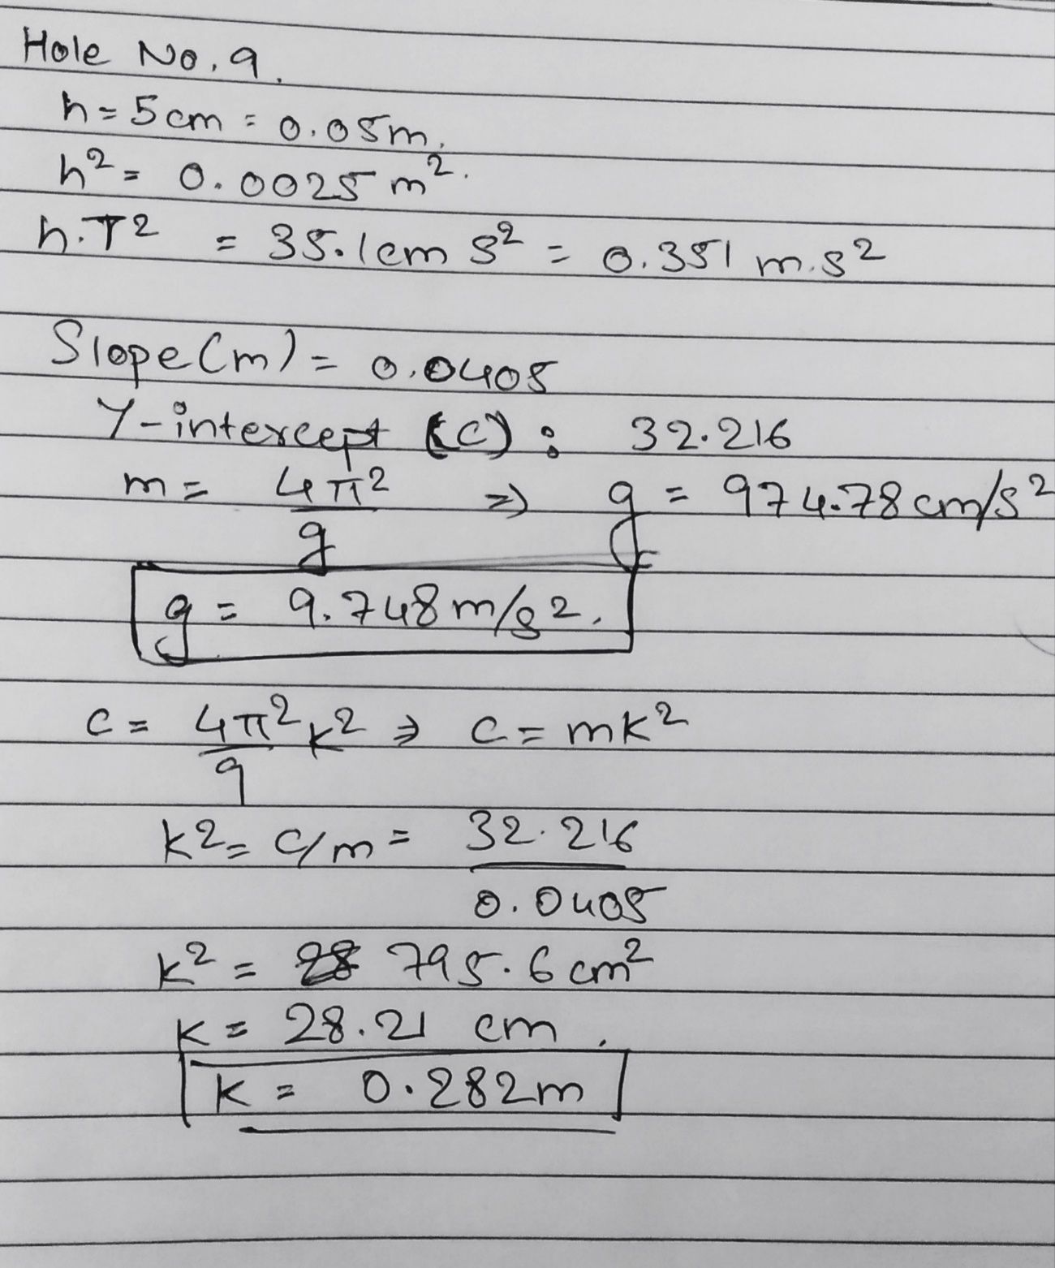

**GRAPH:**

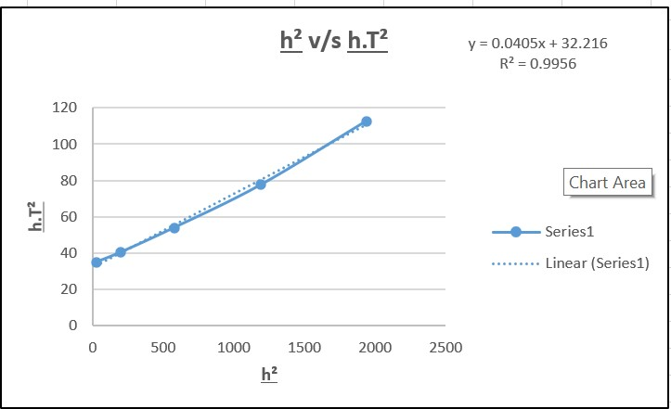

**Slope of the best fit line is= 0.0405**

**Y intercept is= 32.216**

**RESULT:**

The value of k from graph is = **28.204 cm= 0.282 m**

The value of g from graph is = **976.7 cm/s2 = 9.78 m/s2**

**Signature of faculty in-charge**